**PF Lab No 2**

**Date 20-01-2025**

**Task 01**

**Display a welcome message.**

**Coding**

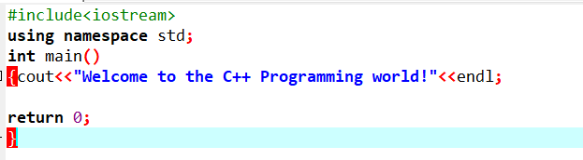

**Output**

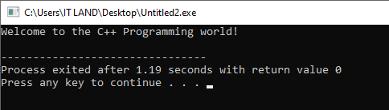

**Question No 1**

**Display following Output.**

There are five Arithmetic Operators:

+, -, *, /, %

All of these can be Applied to all Data types.

**Coding and its Output**

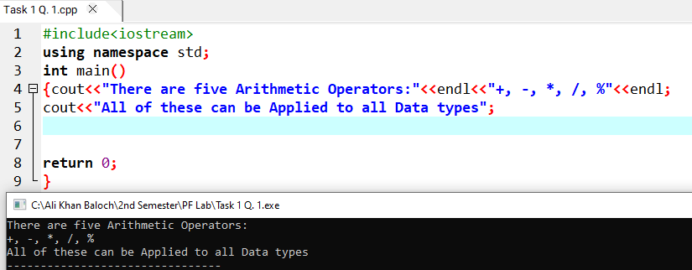

**Question No 2**

**Write a program to Calculate the Average of three numbers given by the user.**

**Input and Output**

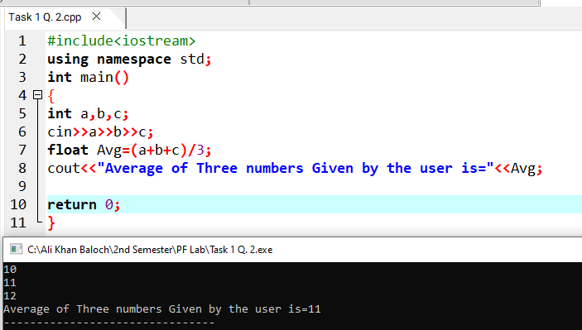

**Question No 3**

**Write a program that takes Temperature value in C from the user and convert it into Fahrenheit using formula**

**F=C*9/5+32**

**Input and Output**

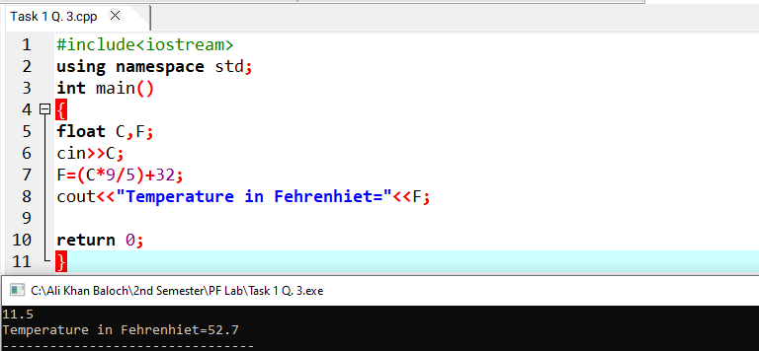

**Question No 4**

**Write a program that takes input X and Y form the User and Calculates Sum Difference and Product**

**Out put should be like**

**You Entered: X and Y**

**Sum=…**

**Difference=..**

**Product=…**

**Input and Output**

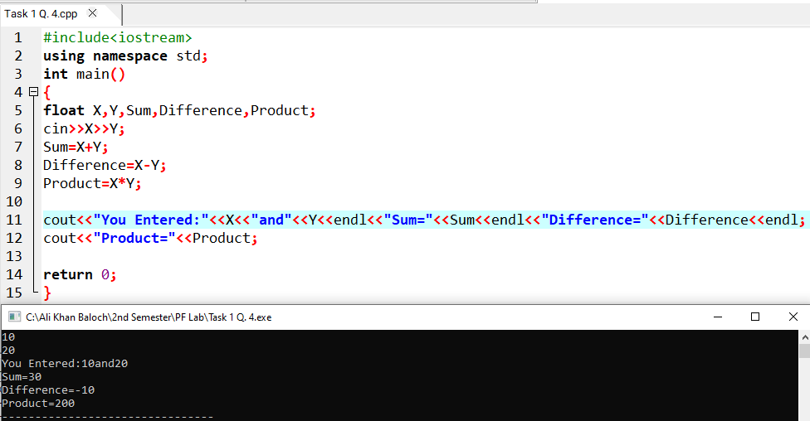

**Question No 5**

**Write a program that Calculates the area of a circle given its radius.**

**Formula=pi*r2**

**Input and Output**

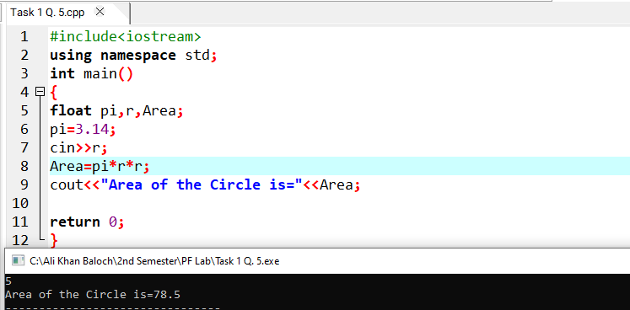

**Question No 6**

**Write a program that Calculates simple interest.**

**Formula=(P*R*T)/100**

**Where P is Principle rate R=rate of interest and T=time**

**Input and Output**

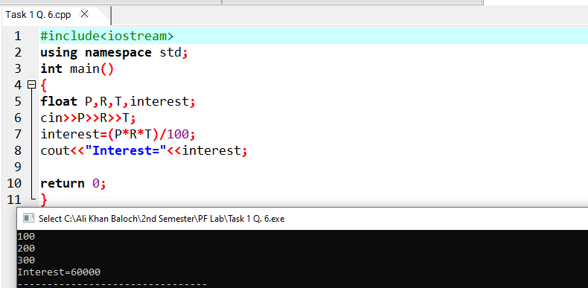

**Question No 7**

**Write a program that Calculates Parameter of a rectangle.**

**Formula=2*(l+w)**

**Input and Output**

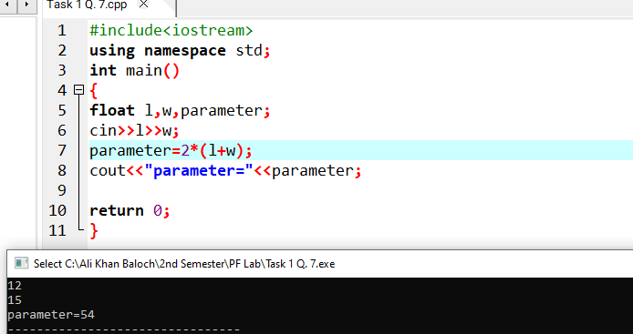

**Question No 8**

**Write a program that takes an input and Calculates its Square and Cube**

**Input and Output**

